****

**30 May 2025**

**Draft Regulations on Dynamic Spectrum Access and Opportunistic Spectrum Management in the Innovation Spectrum 3800 – 4200 MHz and 5925 – 6425 MHz**

Contents

1. Introduction 3

2. Regulatory Fairness 3

3. Future FSS Needs in the 3800 – 4200 MHz band 4

4. 3600 – 3800 MHz band 5

5. Dynamic Spectrum Access and Opportunistic Spectrum Management 5

6. A: Summary Results of Simulations and Trials 6

7. Measures to Prevent Harmful Interference 8

8. Conclusion 10

# **Introduction**

* 1. SENTECH thanks the Independent Communications Authority of South Africa (ICASA) (“Authority”) for the opportunity to make a submission on the *Draft Regulations on Dynamic Spectrum Access and Opportunistic Spectrum Management in the Innovation Spectrum 3800 – 4200 MHz and 5925 – 6425 MHz*, published in Government Gazette No.52415 on 28 March 2025 (“Draft DSA Regulations”).
  2. SENTECH seeks the opportunity to make an oral presentation on the DSA Regulations.

# **Regulatory Fairness**

* 1. SENTECH is concerned that the DSA process falls short of regulatory fairness with respect to equity, transparency, inclusivity, and consistently applying similar principles or regulatory frameworks across all stakeholders.
  2. Taking into consideration the spectrum caps principle introduced in the *Invitation To Apply on the Licensing process for IMT in respect of the provision of Mobile broadband Wireless Access Services*, as published in Government Gazette No. 45628 as published on 10 December 2021, the objectives of the Draft DSA Regulations can be better served by providing access to the high-demand spectrum listed in the table below:

|  |  |  |  |  |
| --- | --- | --- | --- | --- |
| **Frequency Band Size** | **Licensee** | **Application** | **Channel Bandwidth applicable** | **Comment** |
| 700 MHz | Unassigned | IMT | 15 MHz (TDD) |  |
| Unassigned | IMT | 2 x 10 MHz (FDD) | Originally targeted for the WOAN |
| 800 MHz | Unassigned | IMT | 5 MHz (TDD) |  |
| Unassigned | IMT | 2 x 10 MHz (FDD) | Originally targeted for the WOAN |
| 2300 MHz | Unassigned | IMT | 40 MHz (TDD) |  |
| 2600 MHz | Unassigned | IMT | 30 MHz (TDD) | Originally targeted for the WOAN |
| 3300 MHz | Unassigned | IMT | 100 MHz (TDD) |  |
| 3500 MHz | Unassigned | IMT | 30 MHz (TDD) | Originally targeted for the WOAN |
| 3700 MHz |  | IMT | 200 MHz | New allocation at WRC23 |

* 1. For rural, undeserved, and remote communities, the bands above are better suited, especially when considering the existing equipment (network and user) ecosystem:
     1. 700 MHz and 800 MHz: Prime for wide-area coverage and rural connectivity.
     2. 2300 MHz and 2600 MHz: Suited for urban capacity and mid-range coverage.
     3. 3300, 3500 and 3700 MHz: Already seen as the key "mid-band" for 5G.
     4. Community networks and SMEs are likely going to struggle to afford C-band equipment, especially when the Authority seems to be dependent on proprietary technology.
     5. Using these mature bands opens opportunities for digital inclusion, localised innovation, and unlicensed or shared access pilots.
     6. These bands are globally harmonised for IMT use and widely adopted in LTE and 5G deployments.
     7. There is a mature and affordable device ecosystem (e.g., smartphones, modems, small cells, routers) that already supports these bands.
     8. Leveraging existing IMT bands for DSA lowers the barrier to entry for smaller operators, rural ISPs, and innovators.
  2. The objective of reducing “barriers to entry and promoting equitable access to spectrum, while encouraging broader participation from non-dominant players, small micro and medium enterprises and communities” can be achieved through a comprehensive, expansive and thorough ‘beauty contest’ process for HDS.
  3. The Authority already has a template that can be modified to apply for the objectives of Draft DSA Regulations, namely: *Invitation to pre-register for Community Television*
  4. *Broadcasting Service and Radio Frequency Spectrum Licences for Multiplex 1 Frequencies* as published on 30 June 2022 in Government Gazette No. 46629.
  5. The Authority can host a virtual workshop followed by a series of in-person Provincial outreach workshops.
  6. These workshops can provide clarity on the terms: non-dominant players, small, micro and medium enterprises, and communities.

# **Future FSS Needs in the 3800 – 4200 MHz band**

* 1. SENTECH is concerned that the proposed introduction of DSA in the 3800–4200 MHz band may impact the long-term planning and operational certainty of GSO Fixed Satellite Services (FSS), given the reliance on C-band due to its propagation characteristics.
  2. The Authority has failed to indicate how future demands of services with PRIMARY allocation will be protected and addressed.
  3. SENTECH argues that the Authority is obliged to comply with Article 1 of the ITU Radio Regulations, in this case, the following provisions:

***5.28*** *3) Stations of a secondary service:*

***5.29*** *a) shall not cause harmful interference to stations of primary services to which*

*frequencies are already assigned or to which frequencies may be assigned at a later date;*

***5.30*** *b) cannot claim protection from harmful interference from stations of a primary*

*service to which frequencies are already assigned or may be assigned at a later date;*

***5.31*** *c) can claim protection, however, from harmful interference from stations of the same or other secondary service(s) to which frequencies may be assigned at a later date.*

# **3600 – 3800 MHz band**

* 1. Over the years, SENTECH has submitted complaints and submissions on Discussion Documents regarding the challenges of operating in the 3600 – 3800 MHz band.
  2. Though the Authority allowed the sub-band 3 600-3 800 MHz to be with BFWA, the practicality is that FSS suffered interference events that took unnecessarily long to resolve. Because of the constant interference, SENTECH has been forced to migrate services to above 3800 MHz.
  3. Despite the migration, SENTECH services still experience interference issues at transmitter sites.
  4. While most of the interfering carriers are in the sub-3800 MHz band, they still caused problems with the downlinks as the LNBS are continuously saturated due to the incoming power levels. This has caused issues with Sentech’s SLA and availability figures.
  5. The adjacent channel interference has increased SENTECH operational costs due to the installation of narrow guard band filters with a band pass of 3800 MHz to 4200 MHZ to reduce the impact of the interference. While this has reduced the incoming levels of the interfering carriers, they are still present on the spectrum plot after the 60 dBs of attenuation provided by the filter.
  6. SENTECH expect the interference to significantly increase once mobile services are introduced in the 3600 - 3800 MHz band.

# **Dynamic Spectrum Access and Opportunistic Spectrum Management**

* 1. SENTECH acknowledges the Authority’s Finding document and position paper on the inquiry into the implementation of dynamic spectrum access and opportunistic spectrum management, Government Gazette No. 50376, dated 26 March 2024.
  2. The Authority concluded that a draft Regulatory Sandbox, “Regulatory Sandbox for public consultation, aiming to facilitate the implementation of the Dynamic Spectrum Access (DSA) and Opportunistic Spectrum Management framework”.
  3. Additionally, the “Authority will develop draft Regulations for Dynamic Spectrum Access and Opportunistic Spectrum Management, inviting written representations from all stakeholders”.
  4. During a meeting with the industry, the Authority emphasised the need to proceed with a regulatory sandbox. One of the ICASA Councillors then, on social media, also indicated how the Authority has decided to proceed with a regulatory sandbox for DSA.
  5. It is therefore confusing when the Authority publishes Draft DSA Regulations, contrary to what was discussed with affected stakeholders.
  6. It is SENTECH’s understanding that the concepts of a regulatory sandbox and formal regulations both aim to facilitate the implementation of Dynamic Spectrum Access (DSA) and Opportunistic Spectrum Management frameworks, but they differ significantly in their approach, flexibility, and scope.
  7. The Regulatory Sandbox process offers a flexible, controlled, and experimental environment to test and refine DSA and Opportunistic Spectrum Management. It focuses on learning and adaptation with limited risk exposure.
  8. The formal Regulations process establishes a stable and predictable legal framework for the wide-scale implementation and operation of DSA and Opportunistic Spectrum Management, ensuring comprehensive risk management and market stability.
  9. It is also acknowledged that both approaches are complementary. The Sandboxes can be used to gather insights and validate concepts that can later inform the development of robust and effective formal regulations.

# **A: Summary Results of Simulations and Trials**

* 1. SENTECH is concerned with the validity of the summary of information provided by the Authority.
  2. The title of what seems like Annexure A, page 29, states that simulations and trials were undertaken, yet the contents only refer to simulations. It is not clear whether the Authority undertook both simulations and trials.
  3. The summary provided does not provide any justification for the characteristics outlined in the Draft DSA Regulations.
  4. The Draft DSA Regulations indicate that devices must be fixed, nomadic, or function virtualised, yet the Authority has failed to provide simulation results of different scenarios based on the intended use of ‘innovation spectrum devices’.
  5. There is therefore no correlation between the results presented and the characteristics stipulated in the Draft DSA Regulations.
  6. The summary provided by the Authority does include all the scenarios, as indicated in *Figure 1*, thereby making the outcome questionable.

*Figure 1: BWA-FSS Interference Scenarios*

* + 1. In fixed, nomadic and mobile scenarios for CPEs, interference is likely even when the terminal is inactive.
    2. The Draft DSA Regulations, the Customer Premises Equipment (CPE) and master device (e.g., Innovation Spectrum Access Point (IS-AP)) do indeed need to maintain periodic communication. In this scenario, it does not necessarily mean that the CPE is "transmitting" in the conventional sense while in sleep mode.
    3. Sleep mode typically refers to a low-power state where the CPE is not actively transmitting user data or engaging in normal operation, but to comply with DSA regulations (e.g., ensuring non-interference and valid channel use), the device might wake periodically from sleep mode to: send keep-alive messages; confirm channel availability; receive updated spectrum availability information; report location or operational status to the master device (IS-AP); etc. These are usually brief, low-duty-cycle transmissions, not continuous communication.

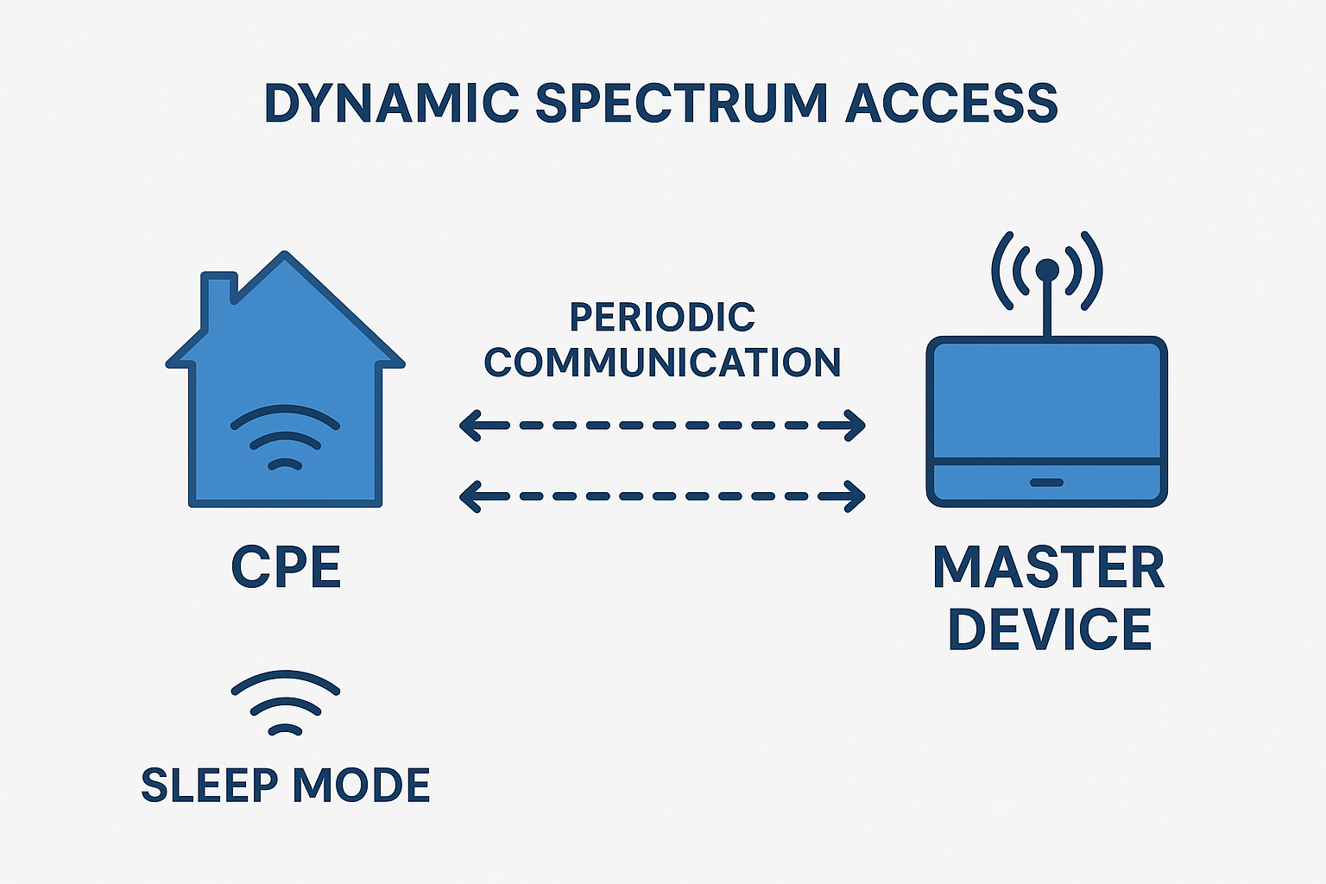

*Figure 2: Inactive interferer*

* 1. **A1.1.3 Key Insights**
     1. The Authority has failed to acknowledge that not all satellite receivers represent individual links. SENTECH distributes content nationally from a single hub station situated in Johannesburg.
     2. In the event the hub station experiences interference, all receivers connected will be affected due to the compromised signal.
     3. A principle of “determining separation distances between FSS and secondary services” is mentioned in the Draft DSA Regulations, but it is not expounded on in terms of compulsory mitigation techniques.
     4. As indicated earlier, in the absence of doing simulations with all relevant scenarios, the proposed mitigation techniques are questionable.
  2. **A1.2 Our Approach to Coexistence**
     1. SENTECH has noted an error in the formula for the Interference-to-Noise ratio presented in the Draft DSA Regulations.
     2. 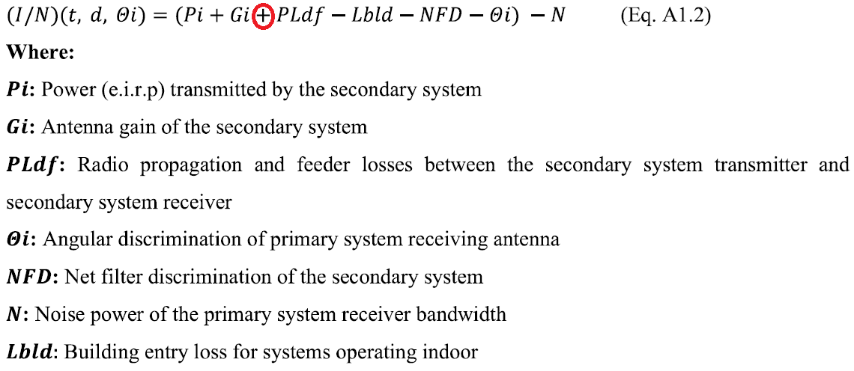It is not clear if the error is just a typo or was transferred into the simulations.

# **Measures to Prevent Harmful Interference**

* 1. SENTECH requires clarity and justification regarding the proposed sub-regulation 11 (1) and 11 (2).
  2. The assignment, annual renewal, etc., of radio frequency spectrum is based on the framework outlined in the Radio Frequency Spectrum Regulations, 2015, as amended, which itself must comply with the National Radio Frequency Plan.
  3. The affected industries should therefore reasonably expect the Authority to have an up-to-date database of spectrum assignments, especially considering the fees assigned to applications and renewals.
  4. It is unreasonable for the Authority to burden licensees with the proposed sub-regulation 11 (1) and 11 (2), when ICASA can coordinate the matter internally.
  5. Additionally, sub-regulation 11 (1), 12 (1), and 12 (6) contradict the EC Act sub-sections 34(3) namely (own emphasis):

*34 (3) The Authority must assign radio frequencies consistent with the* ***national radio frequency plan*** *for the use of radio frequency spectrum by licence holders and other services that may be provided pursuant to a licence exemption.*

* + 1. The National Radio Frequency Plan outlines rules concerning the ***Structure of the Table of Frequency Allocations,*** especially***Column 1: ITU Region 1 Allocations and footnotes,*** and ***Column 2: South African allocations and footnotes:***

***Column 1 - ITU Region 1 Allocations and footnotes***

*This column shows the type of radiocommunications service allocated to the frequency band by ITU. These allocations are defined in the ITU Radio Regulations. Entries in UPPER CASE denote primary services while entries in lower case denote secondary services as defined in the ITU Radio Regulations. Footnotes (e.g., 5.149) are the footnotes to the Table of Frequency Allocations as detailed in Article 5 of the Radio Regulations.*

*…* ***Secondary services*** *are on a non-interference and non-protection basis (NINP) to the* ***primary services****. Spectrum assigned on a secondary basis means that the secondary station: (i) cannot cause harmful interference to stations of primary services to which frequencies are already assigned or to which frequencies may be assigned at a later date; (ii) cannot claim protection from harmful interference from stations of a primary service to which frequencies are already assigned or may be assigned at a later date, however; (iii) can claim protection from interference from stations of the secondary service(s) to which frequencies may be assigned at a later date.*

***Column 2 – South African allocations and footnotes***

*This column indicates the allocations of radiocommunication service(s) specified for South Africa, based on Article 5 of the ITU Radio Regulations. Names of services are based on the definitions in the ITU Radio Regulations and footnotes relevant to South Africa are included. The allocations highlighted with UPPER-CASE letters correspond to primary status allocations; the allocations with secondary status are written in lower-case.*

* + 1. Neither the EC Act nor the National Radio Frequency Plan has any provision that elevates the proposed sub-regulation 12(1) and 12 (6), including the power to override the Radio Frequency Spectrum Regulations, 2015, as amended, without following the repealing process.
    2. The regulatory basis for rules of protection between PRIMARY and secondary services is clearly outlined in the National Radio Frequency Plan, empowered by section 34 of the ECA.

# **Conclusion**

* 1. SENTECH is concerned that the DSA process falls short of regulatory fairness with respect to equity, transparency, inclusivity, and consistently applying similar principles or regulatory frameworks across all stakeholders.
  2. SENTECH is concerned that the proposed introduction of DSA in the 3800–4200 MHz band may impact the long-term planning and operational certainty of GSO Fixed Satellite Services (FSS), given the reliance on C-band due to its propagation characteristics.