General Notices • Algemene Kennisgewings

RESPONSES TO THE ENQUIRY-24 December 2025

INDEPENDENT COMMUNICATIONS AUTHORITY OF SOUTH AFRICA NOTICE 3644 OF 2025



ELECTRONIC COMMUNICATIONS ACT, 2005 (ACT NO. 36 OF 2005)

NOTICE OF INTENTION TO CONDUCT AN INQUIRY INTO NEW INDIVIDUAL ELECTRONIC COMMUNICATIONS NETWORK SERVICE LICENCES


The Independent Communications Authority of South Africa hereby publishes a notice of its intention to conduct an Inquiry into new Individual Electronic Communications Network Service licenses in terms of section 4B of the Independent Communications Authority of South Africa Act, 2000 (Act No. 13 of 2000), to the extent reflected in the Schedule.

Mothibi Ramusi Chairperson

Date: 21
/ 11
/2025

NOTICE OF INTENTION TO CONDUCT AN INQUIRY INTO NEW INDIVIDUAL ELECTRONIC COMMUNICATIONS NETWORK SERVICE LICENCES

- Introduction

The Independent Communications Authority of South Africa (“the Authority”) hereby gives notice of its intention to conduct an Inquiry into new Individual Electronic Communications Network Service licenses (“I-ECNS licenses”) in terms of section 4B (2) of the Independent Communications Authority of South Africa Act, 2000 (Act No. 13 of 2000) (“ICASA Act”).

- Background and Legislative Framework

  - The Inquiry follows the policy direction contained in Government Gazette No. 53215 of 22 August 2025 issued by the Minister of Communications and Digital Technologies (“the Ministerial policy direction”) to ICASA in terms of section 3(2) of the Electronic Communications Act, 2005 (Act No. 36 of 2005), as amended (“the ECA”).

- Purpose of the Inquiry

  - The purpose of the Inquiry is to consider the following:

    - whether or not the implementation of the framework in the ECA, which allows for the transfer of individual electronic communications network services and electronic communications service licenses, has been effective and efficient with regard to the promotion of competition within the sector;

    - the demand for and need to invite, accept and consider applications for new individual electronic communications network services licenses;

    - whether new individual electronic communications network service licenses will promote the objects of the ECA and specifically improve competition in the market for individual electronic communications network services;

    - whether or not and to what extent new individual electronic communications network service licenses will contribute to the universal provision of electronic communications networks; and

    - Whether the benefits of new individual electronic communications network service licenses outweigh the costs, including the cost to the Authority, of monitoring and enforcing compliance with any such licenses, and the impact on the environment.

  - It should be noted that Class Electronic Communications Network (“Class ECN”) and Electronic Communications Service (“Class ECS”) licenses, Broadcasting Service (“BS”) licenses, and Radio Frequency Spectrum (“RFS”) licenses do not fall within the scope of this Inquiry, and are therefore not currently being considered by the Authority.

- The Inquiry Process

The Authority will commence and conduct the Inquiry in a series of phases as follows:

  - Phase 1 (commencement of the Inquiry)

    - The Authority publishes this notice to conduct an Inquiry into new I-ECNS with an accompanying Questionnaire, in the Government Gazette.

    - Stakeholders must submit written responses to the questionnaire within forty-five (45) working days from the date of publication of this Notice and accompanying Questionnaire in the Government Gazette.

    - The Authority may request one-on-one meetings in relation to information submitted by a stakeholder, where necessary to clarify information that is submitted.

  - Phase 2 (Discussion Document)

Publication of the Discussion Document in the Government Gazette for a period of forty-five (45) working days.

  - Phase 3 (Public Hearings on the Discussion Document)

The Authority may hold public hearings and confirm details of the hearings in a notice to be published in the Government Gazette.

  - Phase 4 (Findings Document)

Within ninety (90) days from the date of conclusion of this Inquiry, the Authority will publish a summary of its findings in the Government Gazette and on the Authority’s website.

- Confidentiality

  - Stakeholders may request confidentiality, in terms of section 4D of the ICASA Act, on any information submitted to the Authority during this Inquiry process.

  - Such request for confidentiality must be accompanied by a confidential and non-confidential version of the stakeholder’s submission.

  - The Authority hereby refers stakeholders to the Guideline for Confidentiality Request and the Form, published on 17 August 2018 in Gazette No. 41839, in order to assist stakeholders when applying for confidentiality.

- Instructions and contact details

  - The Authority requests relevant information and opinions from stakeholders to assist in carrying out this Inquiry. Stakeholders are therefore invited to add valuable input into the Inquiry by completing the relevant sections of this questionnaire.

  - In addition to commenting on the matters which the Ministerial Policy Direction requires the Authority to consider, stakeholders are encouraged to provide any other information that may support the Inquiry. Numerical data (where applicable) should be provided electronically in Microsoft Excel.

  - When providing written responses, as well as supporting evidence and or data, stakeholders are requested to indicate clearly to which question the information pertains.

  - All submissions in terms of the questionnaire must be for the attention of the Project Manager, Mr Peter Mailula, by email to iecns-inquiry@icasa.org.za and pmailula@icasa.org.za OR by hand delivery, with a digital copy on a USB, marked specifically for attention:

Mr Peter Mailula
Independent Communications Authority of South Africa 350 Witch-Hazel Road, Eco-Park
Centurion 0157

  - All clarity-seeking questions relating to this Inquiry must be directed to Mr Pascalis Adams on 012 568 4085 or at padams@icasa.org.za, Mr Peter Mailula on 012 568 3657 or at pmailula@icasa.org.za.

INQUIRY INTO INDIVIDUAL ELECTRONIC COMMUNICATIONS NETWORK SERVICE AND INDIVIDUAL ELECTRONIC COMMUNICATIONS SERVICE LICENCES

Questionnaire to industry participants and stakeholders

CONTACT DETAILS FOR RESPONDENT OR REPRESENTATIVE OF THE RESPONDENT
Please complete and include the table below in your submission. Where there is more than one contact person, please include the full details of the additional contact person/s in the format provided below.

Organization | MAKHAGA INC
Name and surname | Sei Mukoma
Position | Consultant
Contact details (telephone number and e-mail address) | makhagaincorporated@gmail.com

SECTION 1: TRANSFER OF INDIVIDUAL I-ECNS AND I-ECS LICENCES FRAMEWORK

The licenses issued under Chapter 3 (Licensing Framework) of the ECA can be classified into two broad categories1:
An Individual Electronic Communications Network Service (I-ECNS) license is a national technology-neutral license that permits a license holder to roll out and operate an electronic communications network and also to provide electronic communications network services in terms of the ECA. An electronic communications network can include, among other things, satellite systems, fixed systems, mobile systems, fibre optic cables, electricity cable systems (used for electronic communications services), and other electronic communications transmission systems.
An Individual Electronic Communications Service (I-ECS) license is a license that permits a license holder to provide electronic communication services (excluding broadcasting services) to its subscribers or end-users nationwide using its own I-ECNS network or via another I-ECNS licensee’s network.

Section 5(6) of the ECA empowers the Authority to issue new licenses for the I-ECNS license category - but only in terms of a Policy Direction issued by the Minister in accordance with section 3 of the ECA. In the absence of such a Ministerial Policy Direction, the Authority cannot and does not issue any new I-ECNS licences.

Despite the Authority being empowered to issue an Invitation to Apply (“ITA”) for I-ECS licenses without any requirement for a Ministerial Policy Direction, the Authority has not done so.

Currently, potential entrants into the electronic communications network and services market can obtain a license through the purchase and transfer of ownership or control of an existing I- ECNS and / or I-ECS license in terms of section 13 of the ECA, subject to ICASA’s prior approval.2 The transfer, or a change in control, of such existing licenses can facilitate market entry and exit.

1 Class ECNS and ECS licenses were not considered as part of this study. Additionally, BS and RFS licenses are not considered as they fall outside of the scope of this Inquiry.
2 Section 13(1) and (2) of the ECA states the following:
- An individual license may not be let, sub-let, assigned, ceded or in any way transferred, and the control of an individual license may not be assigned, ceded or in any way transferred, to any other person without the prior written permission of the Authority.
- An application for permission to let, sub-let, assign, cede or in any way transfer an individual license, or assign, cede or transfer control of an individual license may be made to the Authority in the prescribed manner.

The Authority has noted with concern the reports of high purchase prices charged by I-ECNS and I-ECS licensees in the market for such licenses, which may create barriers to entry and expansion - particularly for small and new entrants in the market.

This Inquiry seeks to determine whether it is preferable to open up the I-ECNS and / or the I- ECS market by means of an appropriate ITA rather than relying on the existing transfer of ownership and control provisions.
Question 1.1: What are your views on the current licensing framework in relation to the sale and transfer of I-ECNS and I-ECS licences (section 13 of the ECA)? In particular, does the current licensing framework hinder or promote competition? In providing your response, please provide reasons supported by evidence or case studies, where applicable.

The current transfer licensing framework does promote competition, albeit at a snail pace because the number of IECNS AND IECS available for transfer is limited, and the purchase price for the IECNS and IECS turn to be exorbitant and prohibitive and create barriers to entry to the market.

We propose the Authority should rather introduce new national IECNS,IECS and Province specific IECNS and IECS for major markets like Kwazulu-Natal, Gauteng and Western Cape. There is demand and need for IECNS and IECS as a pair not separately.

Question 1.2: In your view, should the Authority intervene in the current sale and transfer market to facilitate the purchase of existing licenses? If yes, to what extent should the Authority intervene? Please motivate your response by providing reasons and any supporting evidence or data.

The Authority must intervene by introducing new National and Province specific IECNS and IECS licenses. The economics of the transfer licensing framework is influenced by supply and demand, hence the exorbitant transfer purchase price for IECNS and IECS. Most of the IECNS and IECS are expensive even though some have no balance sheet per se, besides the licenses, no market cap.

Question 1.3: What other considerations or interventions would be useful for the Authority to consider regarding the effectiveness and efficiency of the current sale and transfer licensing framework so as to promote competition?

The most effective framework to promote competition is to introduce new National and Province specific IECNS AND IECS Licenses.

SECTION 2: THE DEMAND FOR NEW INDIVIDUAL ECNS LICENCES

The table below depicts the breakdown of the number of licenses issued by the Authority as at 31 October 2025.
Total number of issued I-ECNS and I-ECS licenses:

 | I-ECNS | I-ECS
Total no. of licenses | 470 | 458
Source: ICASA database (2025)

As at 31 October 2025, the Authority had approved a total of 171 applications for transfer of ownership and control of I-ECNS and I-ECS licenses since the 2008/09 financial year (an average of 10 applications per annum). The majority of the approved applications were transferred as pairs of I-ECNS and I-ECS licenses.

Figure 1: Approved transfer applications transferred as a pair (I-ECNS and I- ECS) or separately (I-ECNS and I-ECS)
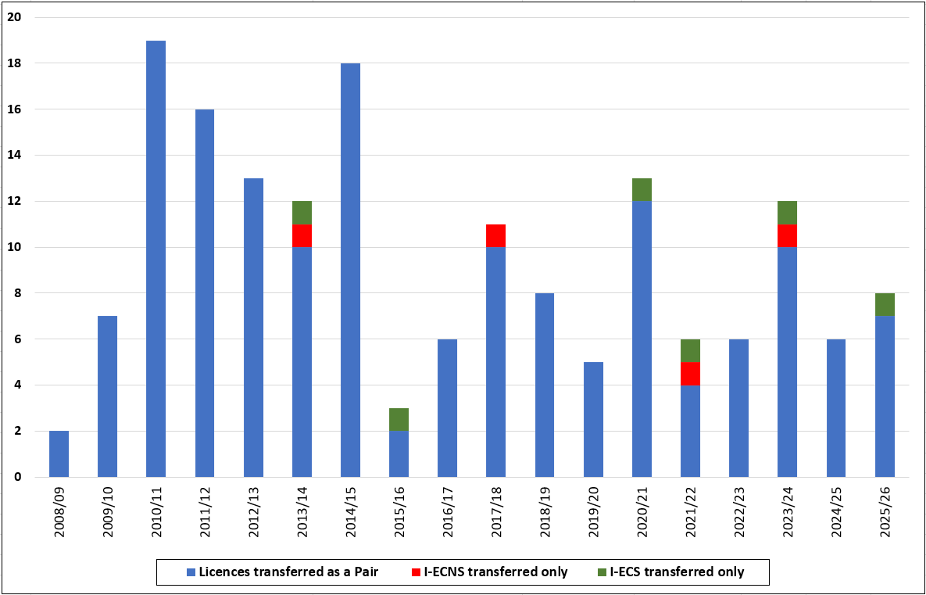
Source: ICASA database (2025)

Further, the majority of the approved applications were in respect of change of ownership with few relating to change in control.

Figure 2: Approved transfer applications change of Ownership vs Control

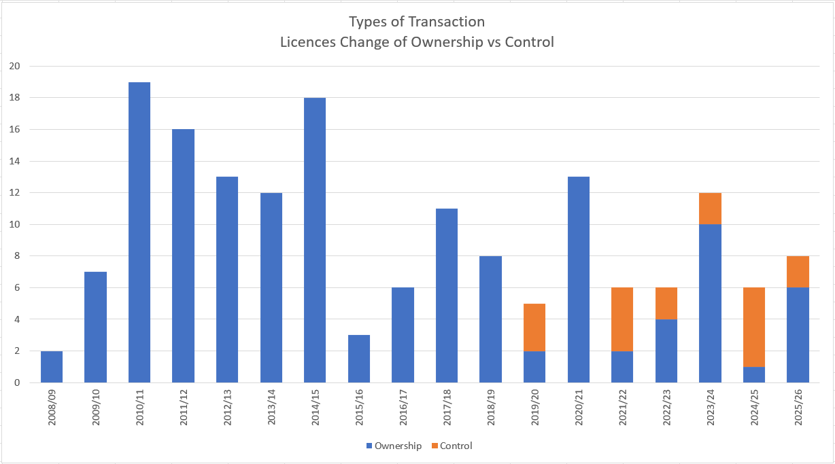
Source: ICASA database (2025)

While the approved transfers of ownership or control of individual licenses may appear relatively low compared to the number of available (and potentially transferrable) individual licenses, it should be noted that this does not necessarily imply low appetite for new individual licenses. The low number of transfers could be attributed to a combination of factors, including:
- Purchase price: Disagreement between the seller/transferor (individual licensee) and the potential buyer/transferee on the purchase price.
- Transfer fees: As of April 2025, ICASA’s transfer fee for a license is R 82 111,00 per I- ECS and I-ECNS license transfer application.
- Package deals: Purchasing both I-ECNS and I-ECS licenses, as opposed to one license, may potentially increase the purchase price.
- Legal and regulatory compliance: Difficulty or reluctance to conform with section 9 (2) (b) of the ECA.

Question 2.1: In your view, are there sufficient market opportunities to justify issuing new I- ECNS and I-ECS licenses? Please motivate your response.

Yes, there is a gap in the market for new National and Province specific IECNS and IECS licenses, as most of the Class ECNS and Class ECS Licensees and prospective Registrants they intend to apply for National and Province specific IECNS and IECS Licenses, particularly there is demand for National and Province specific IECNS and IECS from major markets of Kwazulu-Natal, Gauteng and Western Cape.

Question 2.2: Have you, or are you aware of any licensee or interested party who has, considered or is considering launching or expanding network infrastructure or providing services in South Africa? What technologies, network architecture and/or spectrum frequencies do you think would be appropriate for any new I-ECNS licensees? Please provide examples or evidence where possible.

There is demand for National and Province specific IECNS and IECS with preference for LTE frequencies and fibre infrastructure.

Question 2.3: If you are an existing licensee, did you acquire your I-ECNS and or I-ECS licenses through the sale and transfer market (i.e. bought from another licensee) or did you obtain them directly from the Authority (not through transfer or change of ownership)? If acquired from the secondary market, please provide details on your experience.

Our Clients acquired IECS and IECNS through transfer licensing process.
Question 2.4: If you have/had I-ECNS and/or I-ECS licenses, have you been approached or have you received unsolicited or solicited interest from an interested buyer to acquire your license? Please elaborate and provide as much information as possible, if applicable.
Our Clients have received unsolicited approaches to acquire IECNS and IECS Licensees. The Purchase price and license valuation is always prohibitive.
Question 2.5: If you have I-ECNS and/or I-ECS licenses and are not intending to sell your license(s) in the next 3 - 5 years, please describe the infrastructure used (mobile, fixed, satellite or combination). Provide a list of services that you currently provide and whether those are provided to private consumers and/or businesses/organizations (or both where appropriate)?Our Clients mostly utilize fibre and wireless infrastructure for Wifi and Cyber Security for business and public institutions.
Question 2.6: Are there any additional points that you think would be useful for the Authority to consider regarding the demand for I-ECNS and I-ECS licenses?
There is significant demand and need for new IECS ANS IECNS at National and per Province Specific.

SECTION 3: WHETHER NEW I-ECNS LICENCES WILL PROMOTE COMPETITION IN THE MARKET FOR I-ECNS
Despite the high number of individual licenses, the electronic communications sector remains highly concentrated, with a few players holding large market shares. The high concentration is mainly driven by the cost structures of the electronic communications sector (high fixed and common costs), which places certain restrictions on the extent of competition in the mobile and fixed services markets. Economies of scale and scope are important to split the high fixed and common costs across different products and increase volumes to reduce unit costs and compete effectively.

It should be noted that the high levels of market concentration, together with the relatively large number of existing individual licenses (i.e. 928), do not in themselves suggest that the issuance of new licenses would not be unwarranted. As highlighted above, the Authority has observed certain dynamics in the secondary market for existing individual licenses that may give rise to barriers to entry or expansion in the market. Furthermore, the potential new and small entrants may for strategic or other legitimate business reasons prefer acquiring new licenses rather than existing licenses.
Question 3.1: In your view, do you believe that new I-ECNS licenses will promote or improve competition in the market? Please substantiate your answer.
There is demand and need for both new IECNS and IECS at a National and Province specific, in particular Kwazulu-Natal, Gauteng and Western Cape, as this will promote competition in the market, improve access and choice for consumers.

Question 3.2: If you answered yes to Question 3.1 above, are there any competition issues or concerns that may hinder the effectiveness of such new I-ECNS licenses in promoting or improve competition? Please provide evidence or examples.
The Authority must license new IECNS and IECS at a National and Province Specific license area, because the demand varies from Province to Province, and in some areas there are enough IECNS but fee IECS, and there is more demand for new IECS licenses. Therefore new IECNS without new IECS may hinder competition in the value chain.

Question 3.3: What regulatory measures, if any, should the Authority consider to remedy the competition concerns you have identified in Question 3.2 above, or to ensure that any new I- ECNS licenses compete effectively with the incumbents? Provide examples of the kinds of remedies you would expect to see.

The effective competition remedies is for the Authority to issue invite and issue new National and Province specific IECNS and IECS licenses.

SECTION 4: POTENTIAL CONTRIBUTION OF NEW I-ECNS LICENCES TO UNIVERSAL ACCESS AND SERVICE
Section 8(4) of the ECA states that “the Authority may by regulation make provision for the designation of licensees to whom universal service and universal access obligations are to be applicable and may prescribe additional terms and conditions in respect of the relevant universal service and universal access obligations on such designated licensees”. Currently, the Authority does not have separate specific regulations on universal access and universal service obligations. Such obligations are included more on an ad hoc basis in the terms and conditions of certain ECNS and ECS licenses.

Question 4.1: In your view, will new I-ECNS and I-ECS licenses contribute to universal access and service within the current electronic communications network and services market? Please explain the mechanisms through which such contribution may occur. Provide any supporting data, case studies, or examples.

The introduction of new National and Province Specific IECNS and IECS will promote universal access, as it is evident that the introduction of IECNS and IECS and Class ECNS and Class ECS, beyond the top 5 IECNS AND IECS national network operators, has seen a significant number of small national and regional network operators who now have significant share of the national and regional markets, as consumers/customers have wide choices from ECS and ECNS operators in the value chain.

Question 4.2: In your view, how should the Authority incorporate universal access and service obligations into the terms and conditions of new I-ECNS and I-ECS licenses to ensure equitable access to communications services across South Africa?

There must be a standard universal access license condition embedded in all IECNS and IECS licenses.

SECTION 5: BENEFITS OF NEW I-ECNS LICENCES VERSUS COSTS, INCLUDING THE COST TO THE AUTHORITY OF MONITORING AND ENFORCING COMPLIANCE WITH ANY SUCH LICENCES, AND THE BURDEN ON THE ENVIRONMENT

Question 5.1: Are there any potential negative consequences associated with the rollout of infrastructure by the new I-ECNS licensees that the Authority should consider?

Roll out of telecommunications infrastructure is good as long it does not lead to uncompetitive consolidation.

We hereby advocate for infrastructure/facilities sharing to reduce costs for the consumer and investors.

Question 5.2 What new or additional benefits, if any, could new I-ECNS licenses provide compared to existing licensees? Please provide examples or evidence of potential improvements such as service coverage, infrastructure rollout, technological innovation, competition, or other market and social benefits.

The new IECNS and IECS licenses will easily invest in AI enabled technology which will improve efficiency and reliability of the network and services.

SECTION 6: ANY OTHER COMMENTS

Question 6.1: Do you have any additional comments regarding this Inquiry process that you would like the Authority to consider?

We strongly propose for the Authority to introduce new National and Province specific IECNS and IECS licenses as per Section 5(3)(a) read with Section 5(2)(a)(c) and Section 5(1) of Electronic Communications Act 36 of 2005 and 2010 Standard Terms and Conditions Regulations, Government Gazette 33294, published on 14 June 2010, this will ensure effective universal access to electronic communications services by consumers in the informal settlements and rural provinces in particular, i.e, Limpopo, Northwest, Mpumalanga.

To be more clear, as the Authority has admitted above that it has powers to invite new IECS licenses, a power that it has not exercised as authorized by the ECA, we urge the Authority to invite new applications for IECS and IECNS, as a proper and affective regulatory intervention to promote competition in the telecoms sector as per the objects of the ECA. A narrow licensing framework focused on IECNS is not in best interest of consumers and investors.

Section 5(6) of the ECA is potentially unconstitutional as it only allows policy directives with regards to IECNS, not IECS. This Section need to be amended accordingly to remove a requirement for ministerial policy directive for licensing of new IECNS licenses, as it contradicts Section 5(3)(a) and Section 5(1) of the ECA, in that both IECNS and IECS already have a licensing framework regulated by the Authority.

The telecommunications market in the whole value chain need to be broadened through
Licensing of both new IECNS and IECS, as what we are witnessing is consolidation of the IECNS licensees, to the detriment of IECS market in the long run, as IECS licensees will have few IECNS to choose from for their network services, if the IECS operator does not have IECNS licenses or network infrastructure/facilities. We therefore urge the Authority and the Minister of Digital Technologies to adopt a long term, futuristic, AI informed and out of the box licensing framework for IECNS and IECS. The telecoms services and network must be open for effective and transparent competition, through more new players in IECNS AND IECS. There is evidence that there are significant number of Class ECNS and Class ECS who are in need to National and Province specific IECNS and IECS. We have requests from Clients on a regular basis, unfortunately the Authority has not yet introduced new licensing framework for National and Province specific IECNS and IECS.

If the Authority only license new IECNS, the prices in the IECS market will continue to be less competitive and affordable.

The Enquiry terms of reference are in contradiction to the findings of the Competition Commission Report cited by the Minister of Communications and Digital Technologies, published on 22 August 2025 , Government Gazette Number 53215,para 1.1 till 1.7.The Findings are clear that there is inadequate access to electronic communications services, which consequently means there is a need and demand for more affordable electronic communications services , through new electronic communications service providers(IECS). Competition remedies and interventions are critical in the services market not network infrastructure level.

Printed by and obtainable from the Government Printer, Bosman Street, Private Bag X85, Pretoria, 0001 Contact Centre Tel: 012-748 6200. eMail: info.egazette@gpw.gov.za
Publications: Tel: (012) 748 6053, 748 6061, 748 6065

