**RESPONSE TO ICASA RADIO FREQUENCY SPECTRUM ASSIGNMENT PLAN CONSULTATION**

**DETAILS OF THE CONSULTATION**

|  |  |
| --- | --- |
| **Document being consulted on:** | **Second draft Radio Frequency Spectrum Assignment Plan for thefrequency band 825 to 830 MHz and 870 to 875 MHz** |
| **Closing Date:** | Friday 26th January 2018. |
| **Responses and enquires to be sent to:** | **Attention:** Mr Manyaapelo Richard Makgotlho  The Independent Communications Authority of South Africa (ICASA)  *Pinmill Farm Block A*  164 *Katherine Street*  *South Africa*  *or*  Private Bag XI0002  Sandton  2146  e-mail: rmakgotlho@icasa.org.za |

**RESPONDING ORGANISATION DETAILS**

|  |  |
| --- | --- |
| **Organisation** | Huawei Technologies SA  Private Bag 89  Benmore 2010  Johannesburg  Tel: +27 (0) 11 -517 9800  Fax: +27 (0) 11 -517 9801 |
| **Contact Person** | |
| **Name** | César Gutiérrez |
| **Title** | Head of Middle East and Africa Wireless Regulatory Policy |
| **Contacts** | Mobile: +34 610 106 559  Email: cesar.gutierrez@huawei.com |
| **OR** | |
| **Name** | Rose Moyo |
| **Title** | Director Enterprise Wireless Solutions |
| **Contacts** | Mobile: +27 763682877  Email: rose.moyo@huawei.com |

**Huawei response to ICASA´s public consultation on the second draft FRSAP for the frequency band 825 to 830 MHz and 870 to 875 MHz**

Huawei would like to raise to ICASA our concerns with regards to potential interference from IMT Base Stations (BS) operating in 870-875 MHz into data networks operating within the licence exemption framework of the Short Range Device authorization in the 865 - 869.65 MHz frequency range.

**Impact of LTE BSs operating in 870-875MHz on licence exempt apparatus in 863-870 MHz**

According to Table 6.6.3.1-2 in the 3GPP 36.104 v15.0.0[1] specification, the spurious characteristic of a LTE BS is:

**Wide Area BS operating band unwanted emission limits for 3 MHz channel bandwidth (E‑UTRA bands <1GHz) for Category A**

|  |  |  |  |
| --- | --- | --- | --- |
| **Frequency offset of measurement filter ‑3dB point, Δf** | **Frequency offset of measurement filter centre frequency, f_offset** | **Minimum requirement (Note 1, 2)** | **Measurement  bandwidth** |
| 0 MHz ≤ Δf < 3 MHz | 0.05 MHz ≤ f_offset < 3.05 MHz |  | 100 kHz |
| 3 MHz ≤ Δf < 6 MHz | 3.05 MHz ≤ f_offset < 6.05 MHz | -15 dBm | 100 kHz |
| 6 MHz ≤ Δf ≤ Δfmax | 6.05 MHz ≤ f_offset < f_offsetmax | -13 dBm | 100 kHz |

According to the draft RFSAP, the new LTE network will be deployed at 870-873MHz. Huawei is planning to commercialize SRDs devices operating according to spectrum Regulations in Government Gazette 38754 and 31127. These devices will transmit at 869.4-869.65MHz (downlink) and 865-868MHz (uplink).

According to the 3GPP specification above, the spurious power from the LTE BS would be as follows:

* **-6dBm/100kHz**@869.65MHz, and
* **-11.5dBm/100kHz**@868MHz.

These unwanted emissions from LTE BSs will result in significant degradation of the performance of apparatus operating in 865 - 869.65 MHz in compliance with the SRDs regulations. Below are examples with different distances to the LTE base station:

**SRD performance degradation due to interference from LTE BS operating in 870-875 MHz**

|  |  |  |  |  |
| --- | --- | --- | --- | --- |
| **Spurious level at 869.65 MHz (at the LTE BS antenna port)** | **Distance between the LTE BS and the SRD device (metres)** | **Isolation**  **(dB)** | **Spurious level at 869.65 MHz (at the SRD input)** | **Coverage degradation (compared to a non-interference scenario)** |
| -6dBm/100k | 100 | 60 | -66dBm/100k | 3% |
| -6dBm/100k | 500 | 75 | -81dBm/100k | 10% |
| -6dBm/100k | 1000 | 81 | -87dBm/100k | 16% |

Because of the high level of spurious, the performance of SRD network decreases rapidly and according to our simulations, the coverage will reduce significantly.

**SRD Performance Degradation: Different Coverage vs. Different Spurious Level**

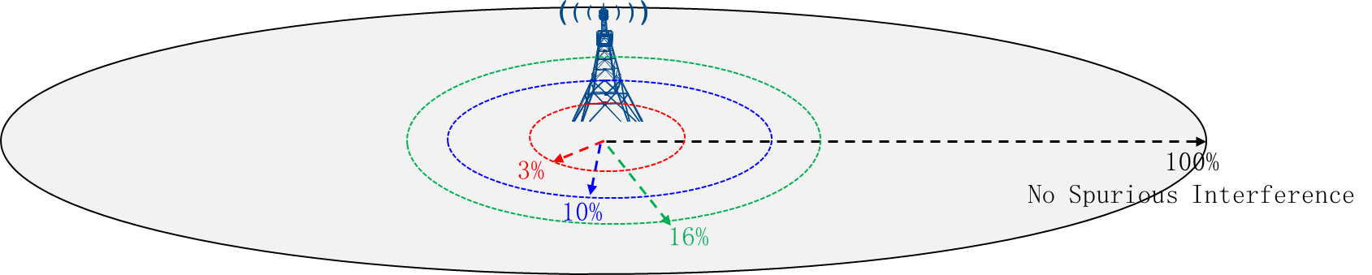

**Huawei’s proposal**

As the new LTE network will be deployed at the adjacent channel of SRD/RFID spectrum (863-870MHz), the spurious from the LTE equipment will be a big interference source. In order to mitigate the interference between, Huawei would like to suggest that:

1. The lowest 1.25MHz (870-871.25MHz) could be reserved as guard band; the frequency gap would ensure the availability of 5dB spurious improvement.
2. In addition the guard band would make it feasible for the LTE equipment manufacturer could do a special design for their filters to mitigate the interference which could result in another 10dB improvement. The total 15dB+ spurious improvement will mitigate the interference situation.
3. For the new LTE BSs deployed in 870-875MHz, the spurious performance @865-870MHz should be clarified clearly by the supplier.

1. <https://portal.3gpp.org/desktopmodules/Specifications/SpecificationDetails.aspx?specificationId=2412>